Differentiation- Questions
June 2019 Mathematics Advanced Paper 1: Pure Mathematics 1
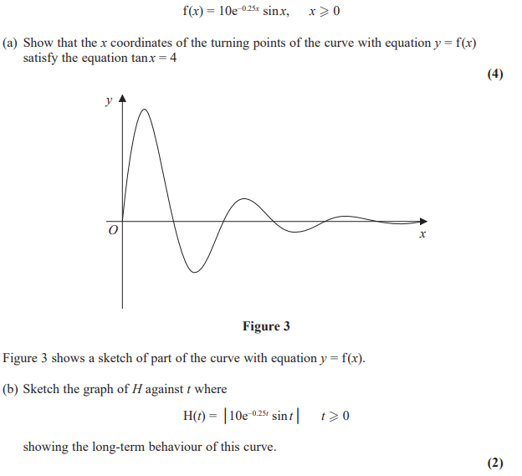

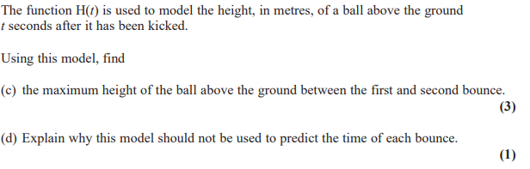

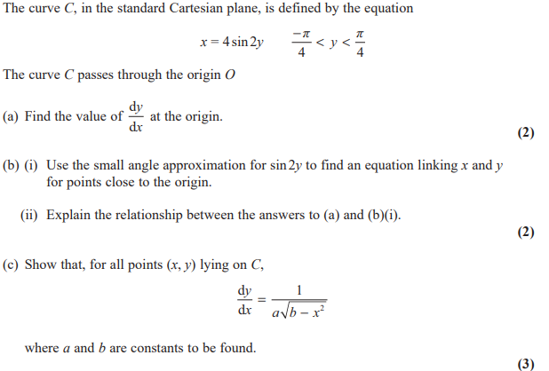

June 2018 Mathematics Advanced Paper 1: Pure Mathematics 1

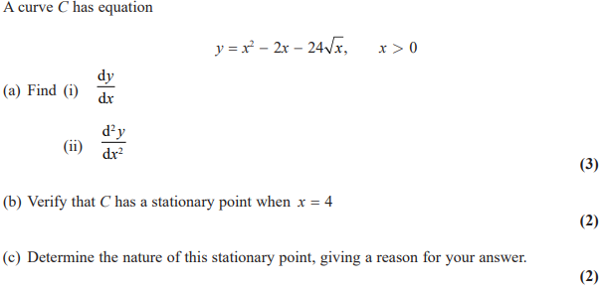

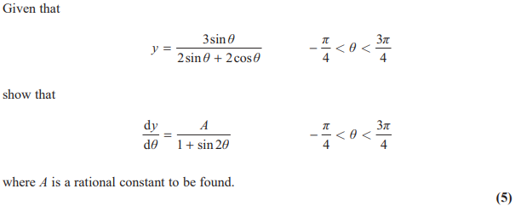

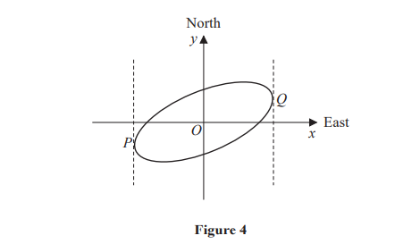
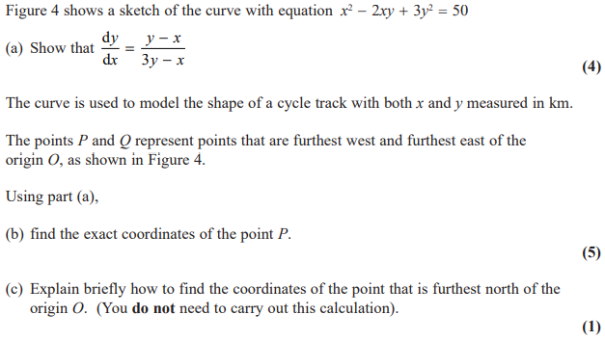

May 2017 Mathematics Advanced Paper 1: Pure Mathematics 1

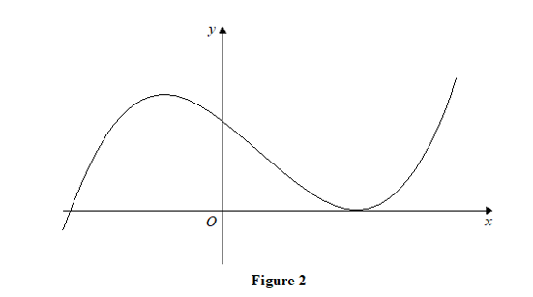
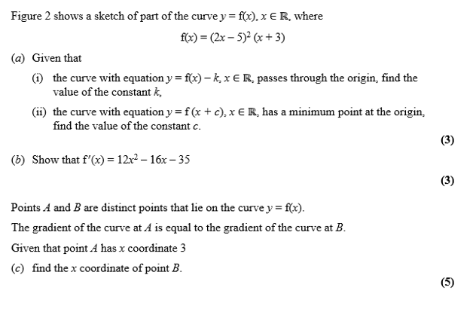

May 2016 Mathematics Advanced Paper 1: Pure Mathematics 1

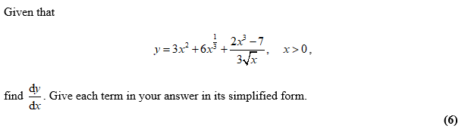

May 2011 Mathematics Advanced Paper 1: Pure Mathematics 2

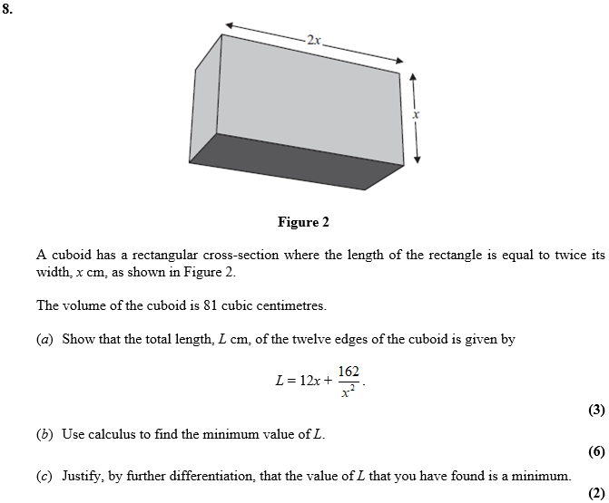

June 2017 Mathematics Advanced Paper 1: Pure Mathematics 3

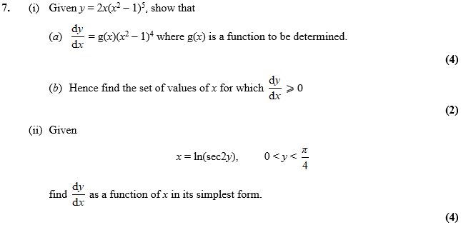

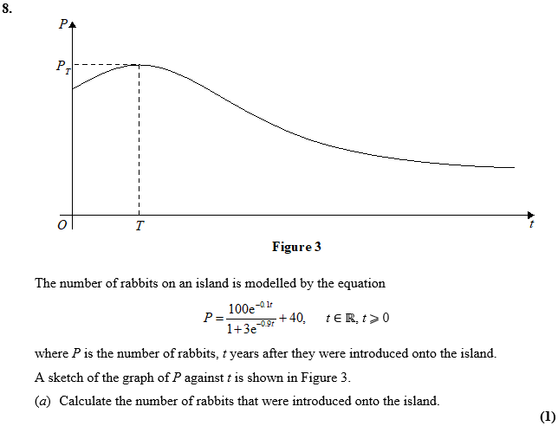
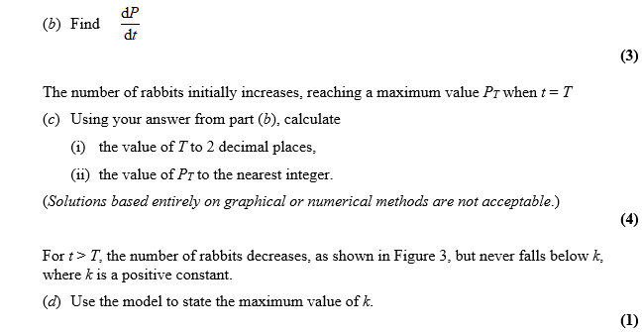
June 2016 Mathematics Advanced Paper 1: Pure Mathematics 3

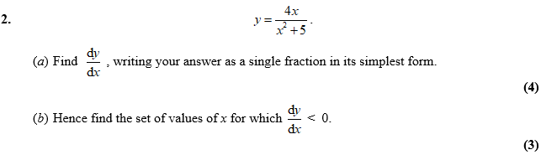

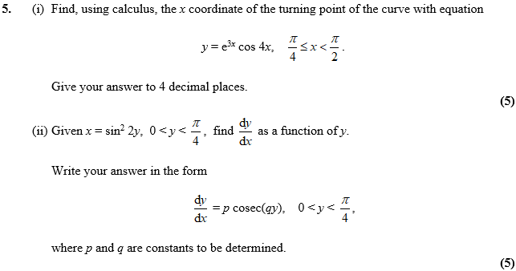

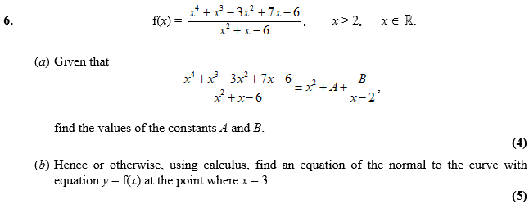

June 2015 Mathematics Advanced Paper 1: Pure Mathematics 3

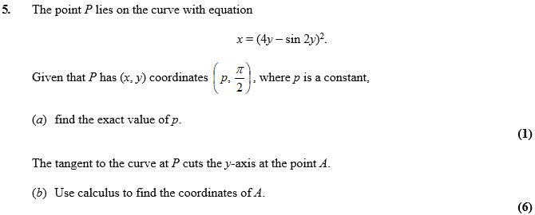

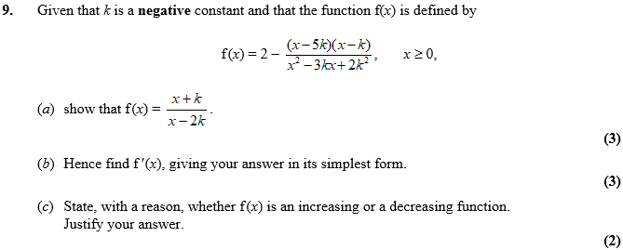
June 2014 Mathematics Advanced Paper 1: Pure Mathematics 3

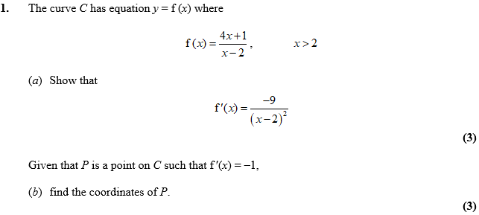

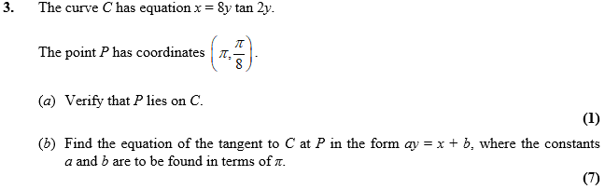

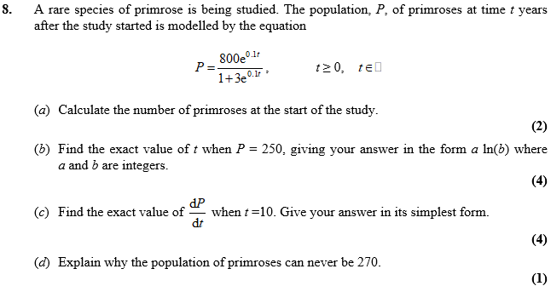
June 2013 Mathematics Advanced Paper 1: Pure Mathematics 3

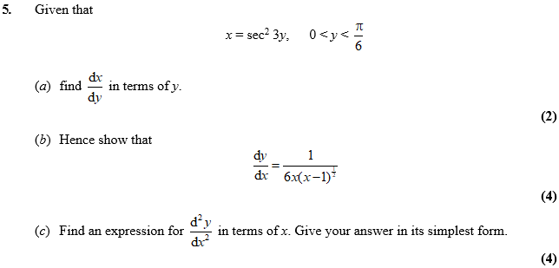

Jan 2013 Mathematics Advanced Paper 1: Pure Mathematics 3

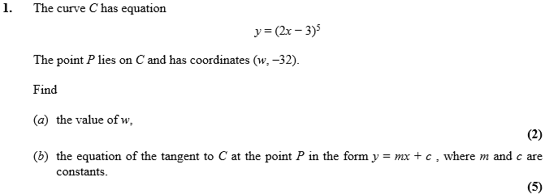

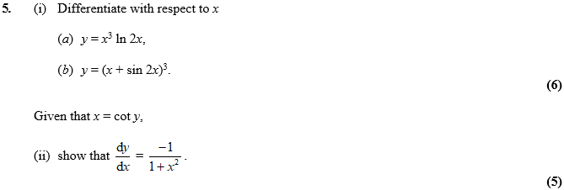

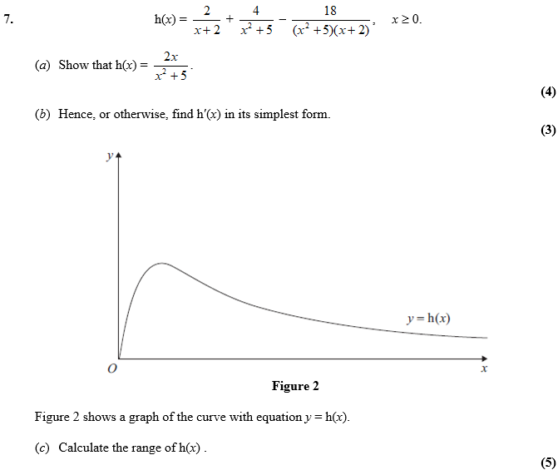

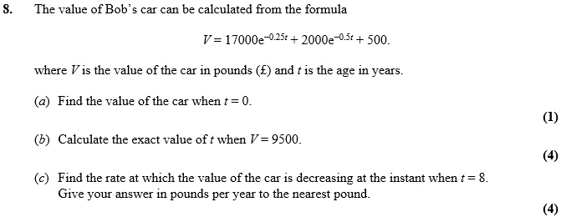

June 2012 Mathematics Advanced Paper 1: Pure Mathematics 3

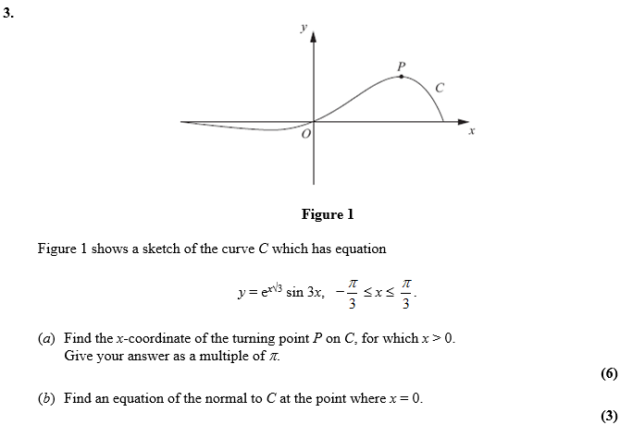

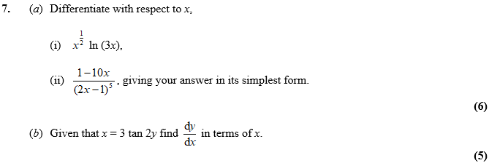

Jan 2012 Mathematics Advanced Paper 1: Pure Mathematics 3

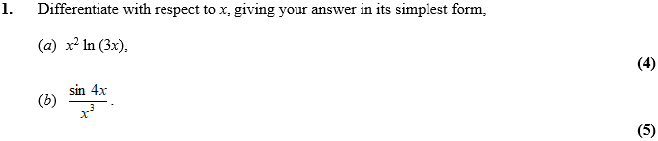

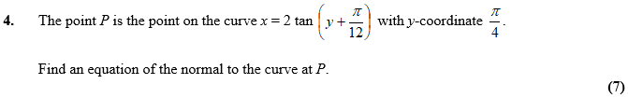

June 2011 Mathematics Advanced Paper 1: Pure Mathematics 3

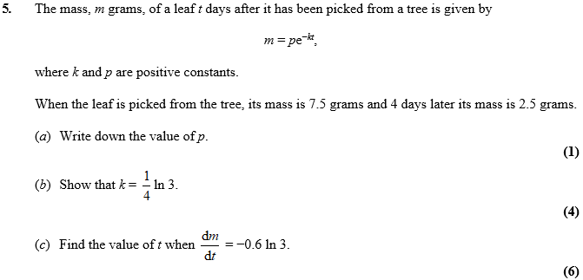

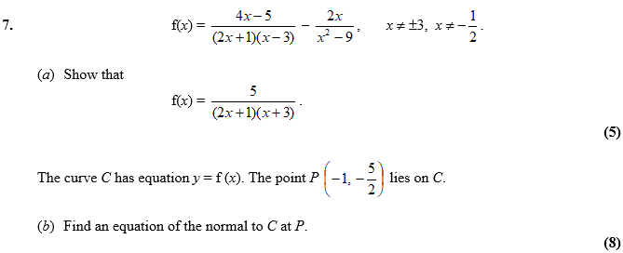

Jan 2011 Mathematics Advanced Paper 1: Pure Mathematics 3

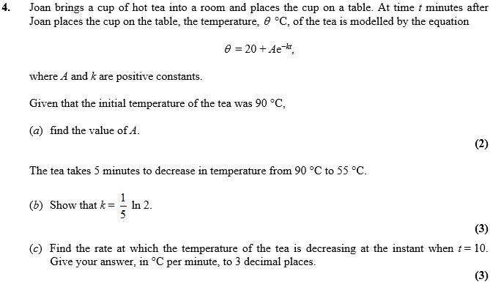

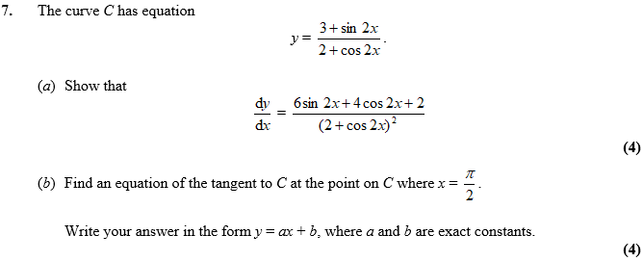

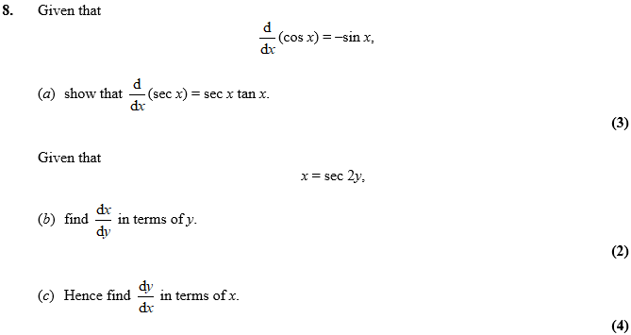

June 2010 Mathematics Advanced Paper 1: Pure Mathematics 3

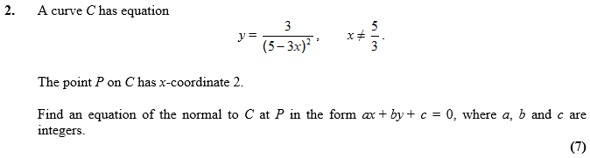

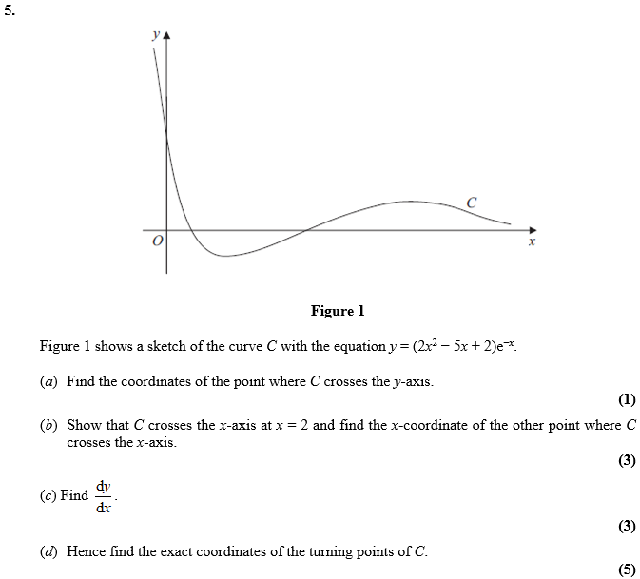

Jan 2010 Mathematics Advanced Paper 1: Pure Mathematics 3

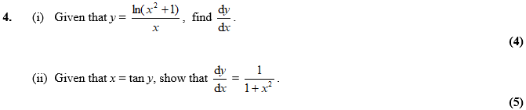

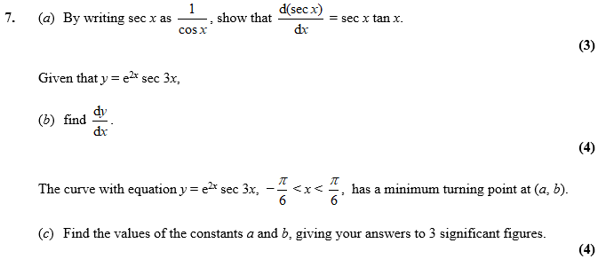

June 2017 Mathematics Advanced Paper 1: Pure Mathematics 4

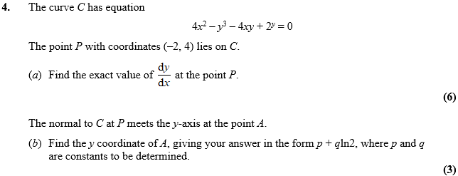

June 2016 Mathematics Advanced Paper 1: Pure Mathematics 4

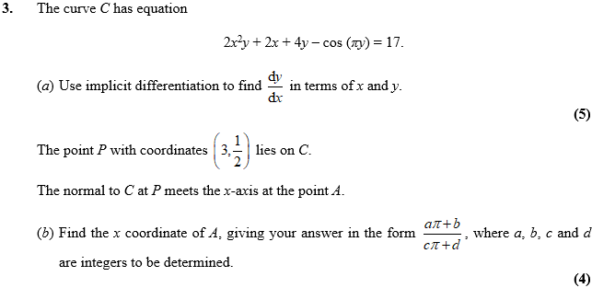

June 2015 Mathematics Advanced Paper 1: Pure Mathematics 4

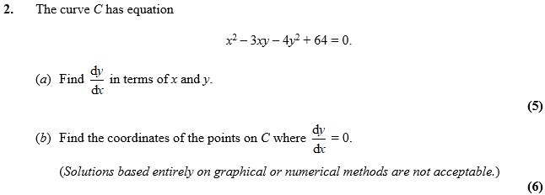

June 2014 Mathematics Advanced Paper 1: Pure Mathematics 4

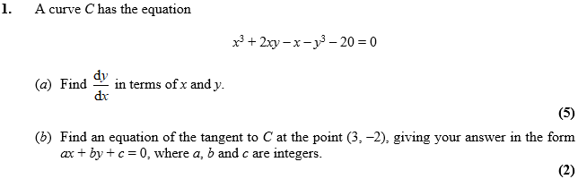

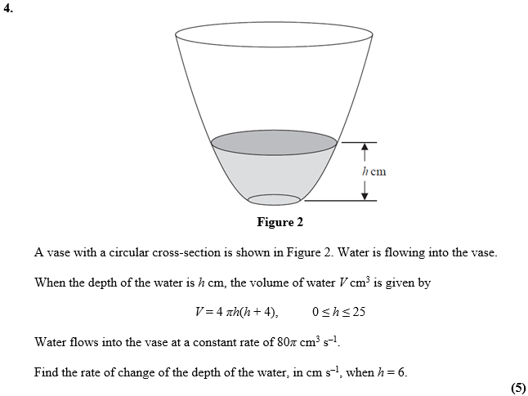

June 2013 Mathematics Advanced Paper 1: Pure Mathematics 4

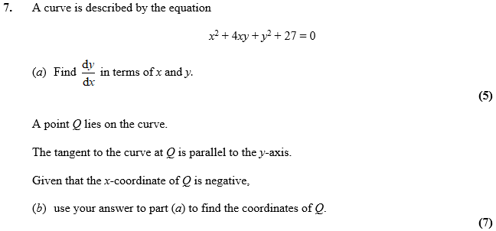

June 2012 Mathematics Advanced Paper 1: Pure Mathematics 4

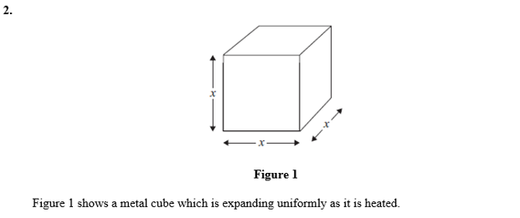
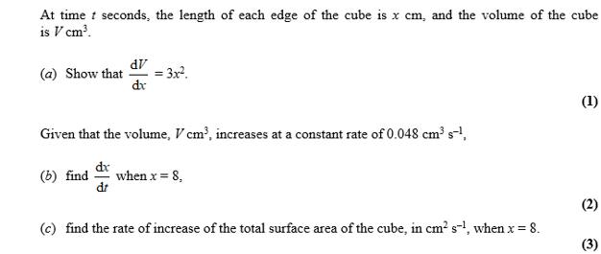

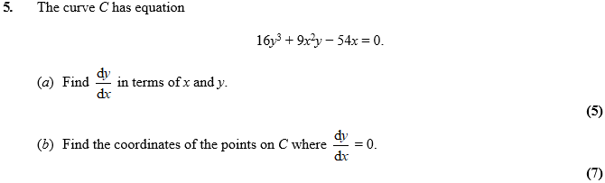

Jan 2012 Mathematics Advanced Paper 1: Pure Mathematics 4

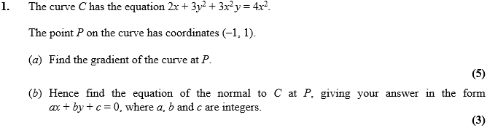

June 2011 Mathematics Advanced Paper 1: Pure Mathematics 4

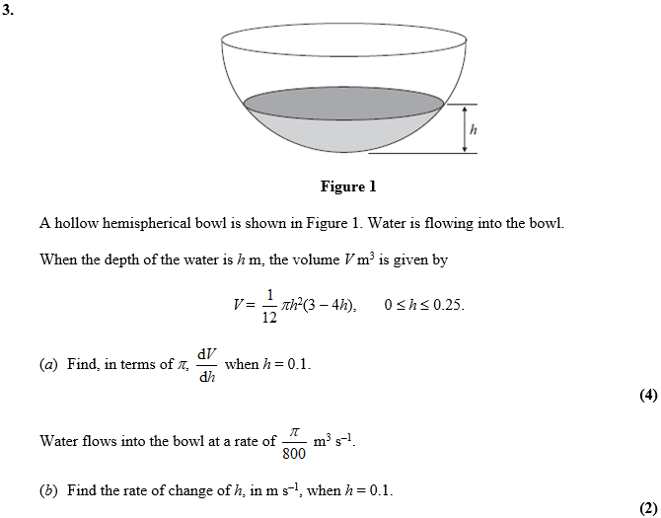

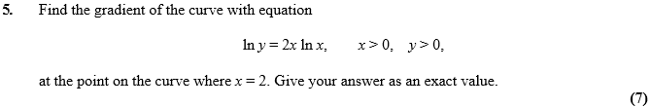

Jan 2011 Mathematics Advanced Paper 1: Pure Mathematics 4

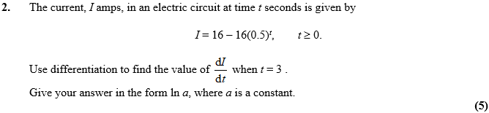
June 2010 Mathematics Advanced Paper 1: Pure Mathematics 4

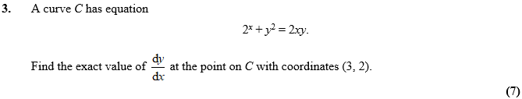

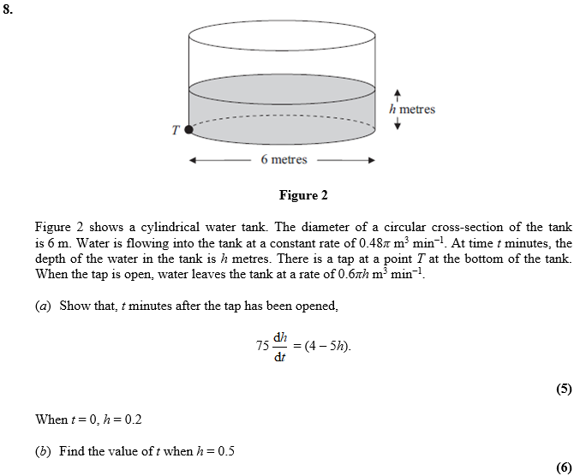
Jan 2010 Mathematics Advanced Paper 1: Pure Mathematics 4

